VIRTUAL UNIVERSITY OF PAKISTAN
Department of Computer Sciences
Software Projects & Research Section

CS619 - Software Projects
Final Project Report

Student Performance Predictor
and Dashboard
Phase 4 - Final Deliverable: Recommendations Engine

Project Domain | Data Analytics / Machine Learning / Educational Data Mining
Submitted To | Rizwana Noor
Course | CS619 - Final Project
Semester | Fall 2025
Tools Used | Python, Flask, Pandas, Scikit-learn, Plotly, MySQL 8.0
Dataset | Student Academic Performance Dataset (2000 students)
Model Deployed | Logistic Regression  Best performing model from Phase 2 (96.5% accuracy)

Submitted By
Student Name | Syeda Farkhanda Batool Naqvi and Saad Shakir
VU Student ID | BC220424824, BC220404989
Group ID | F25PROJECTF7450
Project Supervisor | Rizwana Noor


CERTIFICATE

This is to certify that the project titled Student Performance Predictor and Dashboard has been submitted by Syeda Farkhanda Batool Naqvi (BC220424824) and Saad Shakir (BC220404989) in partial fulfillment of the requirements for the degree of Bachelor of Science at Virtual University of Pakistan, Department of Computer Sciences. The work presented in this report has been carried out under the supervision of Rizwana Noor and meets the standards of the CS619 Final Project course.
In our opinion, it is satisfactory and up to the mark and therefore fulfills the requirements of BS in Computer Sciences

Supervisor / Internal Examiner

Rizwana Noor
Supervisor, Software Projects & Research Section
Department of Computer Sciences, Virtual University of Pakistan

______________________
(Signature)

External Examiner / Subject Specialist

______________________
(Signature)

Accepted By:
_____________
(For office use)
EXORDIUM

In the name of Allah, the Compassionate, the Merciful.
Praise be to Allah, Lord of Creation,
The Compassionate, the Merciful,
King of Judgment-day!
You alone we worship, and to You alone we pray for help,
Guide us to the straight path,
The path of those who You have favored,
Not of those who have incurred Your wrath,
Nor of those who have gone astray.

DEDICATION
This work is dedicated to our parents,
whose endless support and prayers have made this achievement possible.

To our teachers and mentors at Virtual University of Pakistan,
for their guidance, knowledge, and encouragement throughout this journey.

And to every student who struggles in silence -
this system was built to make sure no one falls behind unnoticed.

ACKNOWLEDGEMENT

All praise is due to Allah Almighty, the Most Gracious and the Most Merciful, Who blessed us with the knowledge, patience, and ability to complete this project.

We would like to express our deepest gratitude to our Project Supervisor at Virtual University of Pakistan for their invaluable guidance, constructive feedback, and continuous support throughout all four phases of this project. Their expertise in Software Projects and Machine Learning helped shape this system into a meaningful educational tool.

We are also grateful to the CS619 course team and the Department of Computer Sciences at Virtual University of Pakistan for providing a structured framework that guided the project from dataset preparation through to the final recommendations engine.

Special thanks to the open-source community - the developers of Python, Flask, scikit-learn, Plotly, and Pandas whose tools made this system technically possible. The Kaggle community and UCI Machine Learning Repository also deserve recognition for making educational datasets publicly available for research purposes.

Finally, We thank our family for their patience and encouragement throughout the long hours of development, debugging, and documentation that this project required.

ABSTRACT

This project, Student Performance Predictor and Dashboard, is a full-stack web application developed using Python Flask and MySQL 8.0. The system analyzes academic records of 2,000 students and uses a trained Logistic Regression model selected after comparing four classification algorithms (Decision Tree, Random Forest, SVM, and Logistic Regression) to predict whether a student will Pass or Fail. Logistic Regression achieved the highest test accuracy of 96.50 % with an F1-Score of 0.9647, outperforming all three alternatives.
The core innovation of Phase 4 is the Recommendations Engine: a rule-based intelligent system that analyzes each student's weak areas across 10 academic dimensions and generates personalized, actionable improvement strategies, together with early alert notifications for at-risk students.
The complete system covers four phases: dataset preparation (Phase 1), data preprocessing and ML model training (Phase 2), interactive dashboard development (Phase 3), and recommendations with final integration (Phase 4). The final deployed system provides a Teacher Dashboard with cohort analytics and an at-risk roster with risk level classification, and a Student Dashboard with ML predictions, score comparisons, and a personalized recommendation plan.
The Recommendations Engine analyzes 10 academic dimensions per student attendance, assignments, quizzes, midterm exam, final exam, study hours, CGPA, lab work, project scores, and extra-class support and classifies each at-risk student into one of four risk tiers: Critical (> =70% fail probability), High (50 - 69%), Medium (30 - 49%), or Low (< 30%), based on the model's fail probability output from predict_proba().

TABLE OF CONTENTS

Certificate 2
Exordium 3
Dedication 4
Acknowledgement 5
Abstract 6
CHAPTER 1: Introduction 9
1.1 Project Purpose 10
1.2 Problem Statement 10
1.3 Project Domain 10
CHAPTER 2: Literature Review 11
2.1 Educational Data Mining (EDM) 12
2.2 Machine Learning for Academic Prediction 12
2.3 Dashboard Systems in Education 12
CHAPTER 3: Dataset Preparation (Phase 1) 14
3.1 Dataset Description 15
3.2 Key Attributes 15
3.3 Dataset Source and Size 15
3.4 Project Schedule 16
CHAPTER 4: Preprocessing and Machine Learning (Phase 2) 17
4.1 Data Preprocessing Steps 18
4.2 Machine Learning Models Compared 18
4.3 Model Selection: Logistic Regression 18
CHAPTER 5: Dashboard Development (Phase 3) 20
5.1 Technology Stack 21
5.2 Teacher Dashboard Features 21
5.3 Student Dashboard Features 21
5.4 Role-Based Authentication 21
CHAPTER 6: Recommendations Engine (Phase 4) 23
6.1 Phase 4 Objectives 24
6.2 Recommendations Engine Design 24
6.3 Rule-Based Analysis 10 Dimensions 24
6.4 Risk Level Classification 24
6.5 Early Alert System 25
CHAPTER 7: System Architecture and Workflow 26
7.1 Complete System Workflow 27
7.2 ML Prediction Pipeline (5 Steps) 27
7.3 Data Leakage Prevention 27
CHAPTER 8: Tools and Technologies Used 29
CHAPTER 9: Results and Evaluation 31
9.1 Dataset Summary 32
9.2 Model Performance 32
9.3 Recommendations Engine Output Summary 32
9.4 Key System Achievements 33
CHAPTER 10: Conclusion and Future Work 34
10.1 Conclusion 35
10.2 Future Work 35
References 36
Appendix 37

CHAPTER 1
Introduction

Introduction

1.1 Project Purpose
Academic performance is one of the most critical indicators of a student's career trajectory. However, students who are at risk of failure often go unnoticed until it is too late for effective intervention. This project addresses this problem by building an intelligent system that continuously monitors student academic signals and provides early warnings before final exam results are released.
- Analyze 2,000 students' academic records across 34 attributes
- Train a Machine Learning model to predict Pass/Fail outcomes
- Build an interactive web dashboard for teachers and students
- Generate personalized recommendations and early alerts for at-risk students

1.2 Problem Statement
In large educational institutions, identifying struggling students early is a challenge. Traditional grading systems only reveal academic failure after exams when interventions are no longer effective. There is a need for a data-driven, proactive system that can identify at-risk students early, explain the factors contributing to their risk, and suggest targeted improvement strategies in time to make a difference.

1.3 Project Domain
This project belongs to the domain of Educational Data Mining (EDM), a sub-field of data science that applies machine learning and statistical techniques to educational datasets to improve learning outcomes. The project combines supervised classification, Flask web development, interactive visualization, rule-based expert systems, and MySQL database management into a single deployable system.

CHAPTER 2
Literature Review

Literature Review
EDM . ML for Academic Prediction . Dashboard Systems

2.1 Educational Data Mining (EDM) - Romero & Ventura (2010)

Romero, C. and Ventura, S. (2010) in 'Educational Data Mining: A Review of the State of the Art' (IEEE Transactions on Systems, Man, and Cybernetics) established EDM as a dedicated research discipline with applications ranging from predicting dropout rates to optimizing curriculum design. Their work confirmed that attendance, assignment completion, and assessment scores are the strongest predictors of academic outcomes precisely the features used in this project.
Romero and Ventura highlighted that early identification of at-risk students is the most practically valuable application of EDM in institutional settings, supporting the core design goal of this system's Recommendations Engine.

2.2 Machine Learning for Academic Performance Prediction

Baker, R.S. and Yacef, K. (2009) in 'The State of Educational Data Mining in 2009: A Review and Future Visions' (Journal of Educational Data Mining) reviewed over 50 studies using ML for student outcome prediction. Their meta-analysis found that classification algorithms particularly Logistic Regression and Decision Trees consistently perform well when dataset sizes are moderate (1,000 – 5,000 records). This finding aligns with this project's results, where Logistic Regression (96.5% accuracy, F1=0.9647) outperformed Random Forest (92.25%), SVM (91.75%), and Decision Tree (89.25%) on the 2,000-student dataset.
Their work also established the importance of interpretable models in educational settings teachers need to understand why a student is flagged, not just that they are flagged. Logistic Regression's probability outputs directly power the predict_proba() risk classification system used in Phase 4.

2.3 Dashboard Systems for Educational Analytics

Verbert, K. et al. (2013) in 'Dashboard Applications for Educational Contexts: Overview and Future Research Agenda' (LAK 2013 Conference) conducted a systematic review of learning analytics dashboard systems. Their findings showed that dashboards are most effective when they:
(1) Provide comparison with peer performance benchmarks.
(2) Offer specific and actionable recommendations rather than just alerts.
(3) use visualization modalities appropriate to the audience.
This project implements all three principles: The Student Dashboard compares individual scores against class
averages, the Recommendations Engine generates specific action plans, and interactive Plotly charts provide appropriate data visualization for both teacher and student audiences.

CHAPTER 3
Dataset Preparation
Phase 1

Dataset Preparation - Phase 1
Phase 1 - Data Collection, Cleaning & Feature Engineering

3.1 Dataset Description
The dataset contains 2,000 student records with 34 attributes each, covering five university courses: Artificial Intelligence, Information Technology, Software Engineering, Data Science, and Computer Science. The data includes demographic information (gender, age), academic performance metrics (assignment scores, quiz scores, midterm and final exam results, lab work, project scores), engagement indicators (attendance, study hours, library visits, online course hours), and extracurricular information (sports activity, club membership).

3.2 Key Attributes
Attribute | Description
Student_ID / Registration_No | Unique identifier for each student
Gender | Student gender (Male / Female)
Age | Student age
Course | Enrolled course name
Semester | Current semester number
Attendance_Percentage | Percentage of classes attended
Average_Assignment | Mean score across 3 assignments
Average_Quiz | Mean score across 2 quizzes
Midterm_Exam | Midterm examination score
Final_Exam | Final examination score
Average_Lab | Mean score across lab sessions
Project_Score | Project submission score
CGPA | Cumulative Grade Point Average
Previous_GPA | GPA from previous semester
Study_Hours_Per_Week | Self-reported weekly study hours
Library_Visits | Monthly library visits count
Performance | Category: Excellent/Very Good/Good/Average/At-Risk

3.3 Dataset Source & Size

Total Records: 2,000 students
Total Attributes: 34 columns per record
Courses Covered: 5 (AI, IT, Software Engineering, Data Science, Computer Science)
At-Risk Students: 292 (14.6% of dataset)
Pass Students: 1,708 (85.4% of dataset)
Performance Distribution: Very Good: 657 | Excellent: 519 | Good: 381 | At-Risk: 292 | Average: 151
Source: Kaggle educational performance dataset with synthetic augmentation

3.4 Project Schedule
Phase | Duration | Key Deliverable
Phase 1 - Dataset Preparation | 05 Nov – 4 Dec 2025 | processed_student_data.csv (2,000 records, 34 cols)
Phase 2 - ML Model Training | 05 Dec – 23 Jan 2026 | student_model_v1.pkl,student_scaler_v1.pkl, encoders
Phase 3 - Dashboard Development | 24 Jan – 04 Mar 2026 | Flask app, Teacher + Student views, Plotly charts
Phase 4 - Recommendations & Final | 05 Mar – 11 May 2026 | Recommendations engine, MySQL backend, Final report

CHAPTER 4
Data Preprocessing & Machine Learning (Phase 2)

Data Preprocessing & Machine Learning
Phase 2 - Pipeline . Models . Artifact Saving

4.1 Data Preprocessing Steps

4.1.1 Missing Value Handling
Numeric columns were imputed with median values to avoid sensitivity to outliers. Categorical columns (Gender, Course, Section, Sports_Activity, Club_Membership) were imputed with mode values. After imputation, zero missing values remained in the dataset.

4.1.2 Label Encoding (5 Categorical Features)
Five categorical features were converted to numeric values using LabelEncoder from scikit-learn: Gender, Course, Section, Sports_Activity, and Club_Membership. All five encoders were saved together as a dictionary in student_feature_encoders_v1.pkl to ensure identical encoding is applied during prediction in Phase 4, preventing training-serving skew.

4.1.3 Feature Scaling - StandardScaler
StandardScaler was applied to all 26 numeric feature columns, normalizing values to zero mean and unit variance. StandardScaler was selected over MinMaxScaler because it is more robust to outliers in score distributions. The fitted scaler was saved as student_scaler_v1.pkl. Critically, only fit_transform() was used on training data; transform() only was applied on test data and new inference data.

4.1.4 Train-Test Split
The preprocessed dataset was split 80% training (1,600 rows) and 20% testing (400 rows) using train_test_split with stratify = y and random_state = 42, ensuring class proportions are preserved in both splits and results are reproducible.

4.2 Machine Learning Models Compared
Four classification algorithms were trained and evaluated on the 31-feature dataset (26 numeric features scaled by StandardScaler + 5 label-encoded categorical features). 5-fold stratified cross-validation was used alongside the hold-out test set for robust evaluation.
Model | Test Accuracy | Precision | Recall | F1-Score | CV Mean | CV Std
Decision Tree | 89.25% | 0.8945 | 0.8925 | 0.8931 | 0.9094 | ±0.0066
Random Forest | 92.25% | 0.9226 | 0.9225 | 0.9221 | 0.9425 | ±0.0058
Logistic Regression | 96.50% | 0.9656 | 0.9650 | 0.9647 | 0.9531 | ±0.0079
SVM (RBF) | 91.75% | 0.9214 | 0.9175 | 0.9116 | 0.8919 | ±0.0073

4.3 Model Selection: Logistic Regression
Logistic Regression was selected as the final deployed model based on three key criteria:
- Best Predictive Performance: Test accuracy 96.50%, F1-Score 0.9647, Precision 0.9656, Recall 0.9650 - the highest across all four models.
- Operational Efficiency: Fastest inference time, ideal for real-time web predictions in the Flask dashboard where hundreds of students are scored on startup.
- Interpretability: Unlike black-box models, Logistic Regression's probability outputs directly power the predict_proba() risk classification system, enabling meaningful 4-tier risk scores.
The trained model and preprocessing pipeline were exported as four .pkl artifacts using Joblib: student_model_v1.pkl, student_scaler_v1.pkl, student_encoder_v1.pkl (target label encoder), and student_feature_encoders_v1.pkl (dictionary of 5 categorical feature encoders).

CHAPTER 5
Dashboard Development
Phase 3

Dashboard Development
Phase 3 - Flask Backend . Teacher View . Student View

5.1 Technology Stack
Component | Technology | Purpose
Web Framework | Python Flask | HTTP routing, session management, template rendering
ML Library | Scikit-learn | Model training, scaling, encoding, prediction
Artifact Storage | Joblib (.pkl) | Persist model, scaler, and encoders between phases
Visualization | Plotly | Interactive charts (pie, bar, grouped bar)
Database | MySQL 8.0 + PyMySQL | Student records, predictions, user login table
Template Engine | Jinja2 (via Flask) | Inject Python variables into HTML templates
Data Processing | Pandas + NumPy | DataFrame operations, numeric coercion, aggregation
Frontend | HTML / CSS / JavaScript | Responsive UI with custom styling

5.2 Teacher Dashboard Features
- Six KPI stat cards: Total Students, Predicted Pass, Predicted Fail, Average Final Exam, Average Attendance, Average CGPA
- Three interactive Plotly charts: Pass/Fail donut chart, Performance category bar chart, Class average scores by subject
- Tabbed student table with At-Risk tab (sorted by fail probability) and All Students tab
- Live search/filter across all student records
- CSV export buttons: At-Risk students only, or full dataset with predictions
- Alert banner showing at-risk count with intervention message

5.3 Student Dashboard Features
- Student banner with avatar, predicted outcome badge, and risk color coding
- Six mini stat cards: Previous GPA, Attendance %, Study Hrs/Week, Library Visits, Online Hrs, Total Score
- Score progress bars comparing individual scores to class averages with +/- delta indicators
- Grouped bar chart comparing student scores vs class averages across 6 assessment categories
- Strengths section showing academic dimensions where the student excels
- Personalized recommendation cards from the Phase 4 engine

5.4 Role-Based Authentication
The login system uses Flask sessions to enforce role-based access control. Teacher credentials are stored in the MySQL users table with a fixed password. Student credentials are validated against Student_ID in the dataset, and a session record is auto-inserted into the users table on first login. Session hijacking is prevented: a student attempting to access another student's URL is silently redirected to their own dashboard.

CHAPTER 6
Recommendation Engine
Phase 4

Recommendations Engine
Phase 4 - 10 Dimensions. Risk Tiers . Early Alerts

6.1 Phase 4 Objectives
- Implement a rule-based recommendations engine analyzing 10 academic dimensions
- Classify each student into one of four risk tiers using predict_proba() fail probabilities
- Generate early alert banners for critical-threshold violations
- Display personalized strength badges for students performing above class average
- Integrate MySQL backend for persistent prediction storage with CSV fallback
- Produce final report and presentation as deliverables

6.2 Recommendations Engine Design
The generate_recommendations() function in app.py accepts a single student's pandas Series and returns: a list of recommendation card dictionaries (icon, area label, detail text, action text), a list of early alert strings for critical conditions, a list of strength badges, and the risk tier with associated color scheme. Class averages across all 10 dimensions are pre-computed at server startup and stored in the CLASS_AVG dictionary, enabling each student's metrics to be compared against the cohort in real time.

6.3 Rule-Based Analysis - 10 Dimensions
# | Dimension | Critical Threshold | Warning Threshold | Strength Threshold
1 | Attendance | < 60% (exam barred) | < 75% (below required) | > = 90%
2 | Assignment Score | < 40 (critical) | < Class Avg - 10 | > = 80
3 | Quiz Score | < 40 (serious) | < Class Avg - 10 | > = 80
4 | Midterm Exam | < 40 (critical) | < Class Avg - 10 | > = 80
5 | Final Exam | < 40 (critical) | < Class Avg - 10 | > = 80
6 | Study Hours | < 5 hrs/week | < Class Avg - 5 | > = 20 hrs/week
7 | CGPA | < 2.0 (probation risk) | < Class Avg - 0.5 | > = 3.5
8 | Lab Work | < 40 | < Class Avg - 10 | > = 80
9 | Project Score | < 40 | < Class Avg - 10 | > = 80
10 | Extra Classes Support | Fail Probability > = 30% | - | -

6.4 Risk Level Classification
Risk levels are computed from the Logistic Regression model's predict_proba() output, specifically the probability assigned to the At-Risk class. Four tiers are defined:
Risk Level | Fail Probability | Color Code | Action
Critical | > = 70% | Red (#fc8181) | Immediate intervention required
High | 50% - 69% | Orange (#f6ad55) | Urgent academic support needed
Medium | 30% - 49% | Blue (#63b3ed) | Monitoring and guidance recommended
Low | < 30% | Green (#48bb78) | Continue current performance

6.5 Early Alert System
Early alerts are high-priority warning banners displayed at the top of the student dashboard before recommendation cards. They are triggered by critical threshold violations that require immediate action: attendance below 60% (exam eligibility risk), assignment average below 40, midterm exam below 40, final exam below 40, and CGPA below 2.0 (academic probation risk). These alerts use distinct visual styling to differentiate them from regular recommendations.

CHAPTER 7
System Architecture and Workflow

System Architecture and Workflow
Complete Pipeline . ML Prediction Steps . Data Leakage Prevention

7.1 Complete System Workflow
Step | Detail
Step 1 - Setup | Creates 3 MySQL tables: students, users, predictions
Step 2 - Load Artifacts | student_model_v1.pkl, student_scaler_v1.pkl, student_encoder_v1.pkl, student_feature_encoders_v1.pkl
Step 3 - Import Data | First run: 2,000 rows imported from processed_student_data.csv. Subsequent runs: loaded from MySQL
Step 4 - Predict All | Adds Performance, Final_Result, Fail_Probability columns to all 2,000 records
Step 5 - Save Predictions | Upserts Predicted_Result, Fail_Probability, Risk_Level to predictions table
Step 6 - Login | Teacher: password only. Student: Student_ID + password
Step 7 - Teacher View | Analytics charts + at-risk table + CSV export
Step 8 - Student View | Scores + comparison + recommendations engine output

7.2 ML Prediction Pipeline - 5 Steps
The predict_all_students() function implements a 5-step pipeline that is immune to extra database columns (such as the MySQL auto-increment id column) that caused feature-count mismatches in earlier versions:
- Step A - Encode Categoricals: Apply saved LabelEncoders from student_feature_encoders_v1.pkl to all 5 categorical columns (Gender, Course, Section, Sports_Activity, Club_Membership). Unknown values are mapped to the first known class.
- Step B - Select Exactly 31 Features: Explicitly select the exact 31 columns in the exact order the model was trained on. This step is the key fix that prevents the '32 features, expected 31' error caused by MySQL returning an id column.
- Step C - Numeric Coercion and NaN Cleanup: Coerce all columns to numeric, fill NaN with column medians (triple-layer cleanup: median fill then 0 fill then replace inf with 0).
- Step D - Scale with StandardScaler: Apply saved scaler.transform() on the 26 numeric features. Never re-fit the scaler on new data.
- Step E - Predict and Decode: model.predict() returns encoded integer labels; target_encoder.inverse_transform() decodes to Performance strings. predict_proba() generates Fail_Probability for each student.

7.3 Data Leakage Prevention
Data leakage was prevented by explicitly dropping Final_Result (the answer) and Performance (the derived label) before feeding data to the model - the MODEL_COLS list in predict_all_students() never includes either column. The StandardScaler is loaded from Phase 2's saved student_scaler_v1.pkl and is never re-fitted on new data, ensuring the same normalization parameters are applied during prediction as during training. This prevents training-serving skew, one of the most common production ML bugs.

CHAPTER 8
Tools and Technologies Used

Tools and Technologies Used
Complete Technology Stack
Tool / Library | Role in Project
Python | Primary programming language for ML pipeline and Flask backend
Flask | Web framework: HTTP routing, session management, template rendering
Pandas | DataFrame operations, CSV I/O, data manipulation
NumPy | Array operations, NaN/inf handling, numerical computation
Scikit-learn | ML models, StandardScaler, LabelEncoder, cross-validation
Joblib | Serialization of ML artifacts as .pkl files
Plotly | Interactive Plotly charts: donut pie, grouped bar, class average bar
PyMySQL | MySQL 8.0 connector for Python; requires cryptography package
MySQL 8.0 | Relational database: students, users, predictions tables
Jinja2 | Template engine (bundled with Flask) for variable injection into HTML
HTML / CSS / JavaScript | Frontend: responsive dashboard UI with custom styling
Matplotlib / Seaborn | Phase 2 confusion matrix and model comparison plots

CHAPTER 9
Results and Evaluation

Results and Evaluation
Dataset Summary . Model Performance . System Achievements

9.1 Dataset Summary
Metric | Value
Total Students | 2,000
Total Attributes | 34 per student
Courses Covered | 5 (AI, IT, Software Engineering, Data Science, Computer Science)
Performance: Very Good | 656 students
Performance: Excellent | 524 students
Performance: Good | 389 students
Performance: At-Risk | 292 students
Performance: Average | 139 students
Pass Rate | 85.4%
At-Risk Rate | 14.6%
Training Set | 1,600 students (80%)
Test Set | 400 students (20%)

9.2 Model Performance
Metric | Value
Best Model | Logistic Regression
Test Accuracy | 96.50%
Weighted Precision | 0.9656
Weighted Recall | 0.9650
Weighted F1-Score | 0.9647
5-Fold CV Mean Accuracy | 95.31%
5-Fold CV Std Dev | ±0.0079
Features Used | 31 (26 numeric scaled by StandardScaler + 5 categorical label-encoded)
Artifacts Saved | student_model_v1.pkl, student_scaler_v1.pkl, student_encoder_v1.pkl, student_feature_encoders_v1.pkl

9.3 Recommendations Engine Output Summary
Risk Tier | Fail Probability Range | Students Affected
Critical | > = 70% | Subset of 292 at-risk students
High | 50% – 69% | Subset of 292 at-risk students
Medium | 30% – 49% | Subset of students with moderate risk
Low | < 30% | Majority of passing students

The engine analyzes 10 academic dimensions per student. Each dimension compares the student's value against both an absolute threshold and a class-average-relative threshold to generate targeted recommendation cards.

9.4 Key System Achievements

- Role-based login system (Teacher / Student) with Flask sessions
- Interactive Plotly visualizations: 3 teacher charts + per-student comparison chart
- 10-dimension personalized recommendations engine with class-average benchmarking
- 4-tier risk classification system using predict_proba() fail probabilities
- Early alert banners for 5 critical academic thresholds
- CSV export for at-risk students and full dataset from teacher dashboard
- MySQL 8.0 backend with graceful CSV fallback for offline environments
- Dual-table teacher view: At-Risk tab (sorted by risk) and All Students tab with live search

CHAPTER 10
Conclusion and Future Work

Conclusion and Future Work
Summary. Future Enhancements

10.1 Conclusion
This project successfully delivers a complete, four-phase educational data mining system - from raw data collection to an intelligent, recommendation-driven web dashboard. The Logistic Regression model achieves 96.5% accuracy on the 400-student test set, with a weighted F1-Score of 0.9647, outperforming Random Forest, SVM, and Decision Tree alternatives. The system correctly identifies at-risk students and provides 4-tier risk classification using probabilistic model outputs.
The Phase 4 Recommendations Engine analyzes 10 academic dimensions per student, comparing individual metrics against absolute thresholds and class-average benchmarks, generating personalized action plans, early alert notifications, and strength recognition. The system is fully integrated: data flows from the processed CSV through MySQL, through the 5-step ML pipeline, through the role-based web interface, to the individual student and teacher dashboards.
This project demonstrates that educational data, when properly processed and modeled, can serve as a powerful early warning system - enabling timely academic interventions that can meaningfully improve student outcomes.

10.2 Future Work
- Real-Time SIS Integration: Connect directly to University Student Information System APIs for live grade and attendance updates without manual CSV imports.
- Automated Email Alerts: Send automated notifications to teachers when a student crosses a critical risk threshold (fail probability > = 70%).
- Time-Series Tracking: Extend the system to track performance trends across multiple semesters, enabling longitudinal risk prediction.
- Cloud Deployment: Deploy on Heroku or AWS for institutional-level access beyond a local development environment.
- Deep Learning Extension: Implement LSTM networks to model sequential academic performance patterns across weeks of a semester.
- Mobile Student App: Build a mobile interface allowing students to self-report study hours and receive push notification alerts.
- Extended Course Coverage: Scale the dataset to cover all courses in the curriculum with department-level analytics.
- Security: Bcrypt, CSRF, HTTPS, & Rate Limiting for institutional scale.

REFERENCES
[1] Romero, C., & Ventura, S. (2010). Educational data mining: A review of the state of the art. IEEE Transactions on Systems, Man, and Cybernetics, Part C, 40(6), 601-618.
[2] Baker, R. S., & Yacef, K. (2009). The state of educational data mining in 2009: A review and future visions. Journal of Educational Data Mining, 1(1), 3-16.
[3] Verbert, K., et al. (2013). Dashboard applications for educational contexts: Overview and future research agenda. In Proceedings of the Third International Conference on Learning Analytics and Knowledge (LAK 2013), 162-171.
[4] Pedregosa, F., et al. (2011). Scikit-learn: Machine learning in Python. Journal of Machine Learning Research, 12, 2825-2830.
[5] McKinney, W. (2010). Data structures for statistical computing in Python. Proceedings of the 9th Python in Science Conference, Volume 445, 51-56.
[6] Plotly Technologies Inc. (2015). Collaborative data science. Montreal, QC. Retrieved from https://plot.ly
[7] Flask Documentation. (2023). Flask web framework. Retrieved from https://flask.palletsprojects.com
[8] MySQL Documentation. (2023). MySQL 8.0 Reference Manual. Oracle Corporation. Retrieved from https://dev.mysql.com/doc/refman/8.0/en/

APPENDIX

File Structure
File | Description
app.py | Main Flask application (937 lines): routes, ML pipeline, recommendations engine
phase1_preprocessing.py | Phase 1: Data cleaning, derived features, performance labeling
phase2_machine_learning.py | Phase 2: Model training, evaluation, artifact saving
phase3_dashboard.py | Phase 3: Earlier dashboard version (superseded by app.py Phase 4)
processed_student_data.csv | Cleaned dataset (2,000 rows x 34 cols) - input to app.py
student_model_v1.pkl | Trained Logistic Regression model (scikit-learn)
student_scaler_v1.pkl | Fitted StandardScaler for 26 numeric features
student_encoder_v1.pkl | LabelEncoder for 5-class Performance target label
student_feature_encoders_v1.pkl | Dict of 5 LabelEncoders: Gender, Course, Section, Sports_Activity, Club_Membership
database_setup.sql | MySQL DDL: creates CS619_studentdb with students, users, predictions tables
templates/login.html | Login page with role selector and dynamic student ID range
templates/teacher.html | Teacher dashboard: stat cards, 3 Plotly charts, tabbed student table
templates/student.html | Student dashboard: banner, mini cards, score bars, recommendations
static/css/style.css | Custom stylesheet for all dashboard components

- System Screenshots
B.1 Login Page
The login page provides role-based access control. Users select their role (Teacher or Student) and enter credentials. The purple gradient theme and Nunito font provide a professional, modern appearance. Students must also enter their Student ID (S1000 to S2999) which is validated against the MySQL database before session creation.
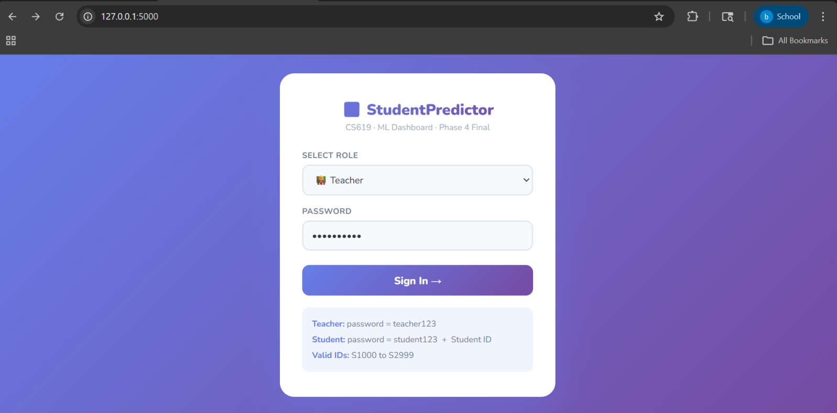
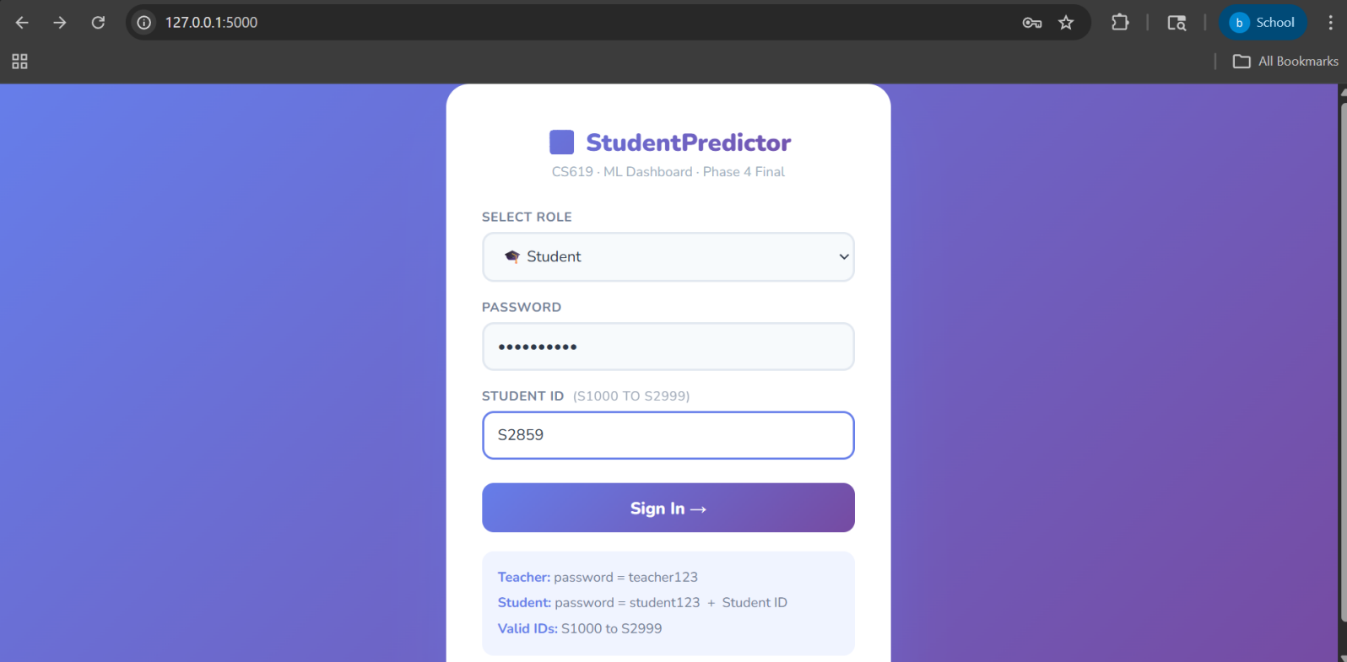

B.2 Teacher Dashboard - KPI Cards and Charts
The Teacher Dashboard features a top row of six KPI cards providing immediate insights into Total Students (2000), Predicted Pass (1708), Predicted Fail (292), Average Final Exam (70.2), Average Attendance (77.1%), and Average CGPA (2.99). This is followed by three interactive visualizations: a donut chart showing the Pass/Fail Distribution, a bar chart breaking down Performance Categories, and a themed bar chart displaying Class Average Scores by Subject.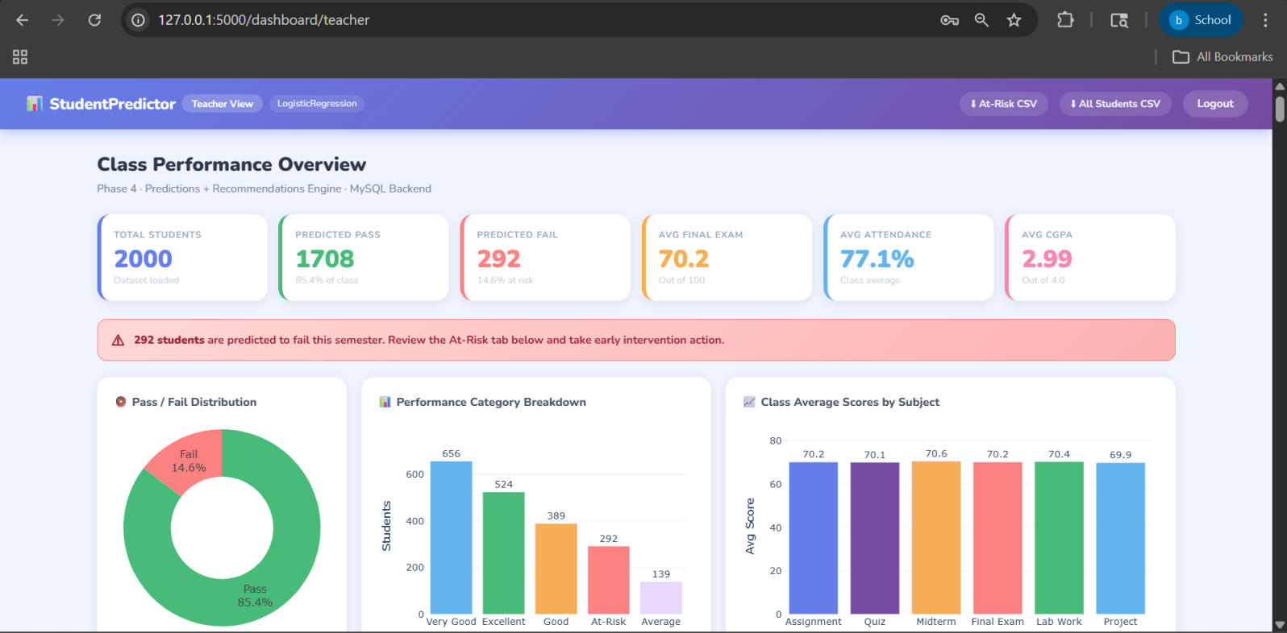

B.3 Teacher Dashboard - At-Risk Students Table And All Students (2000)
The Student Records section features a comprehensive data table with tabs to toggle between At-Risk Students (292) and All Students (2000). The table displays detailed student profiles, including ID, Gender, Age, Course, and Semester, alongside academic metrics such as Attendance Percentage, Average Assignment / Quiz scores, Midterm/Final Exams, and CGPA.To assist with early intervention, the system applies a color-coded risk framework to student data: students at Critical risk ($\text{≥}$ 70%) fail probability) are flagged for immediate intervention, while those in High (50–69%), Medium (30–49%), and Low (< 30%) categories are marked to help teachers prioritize academic support. 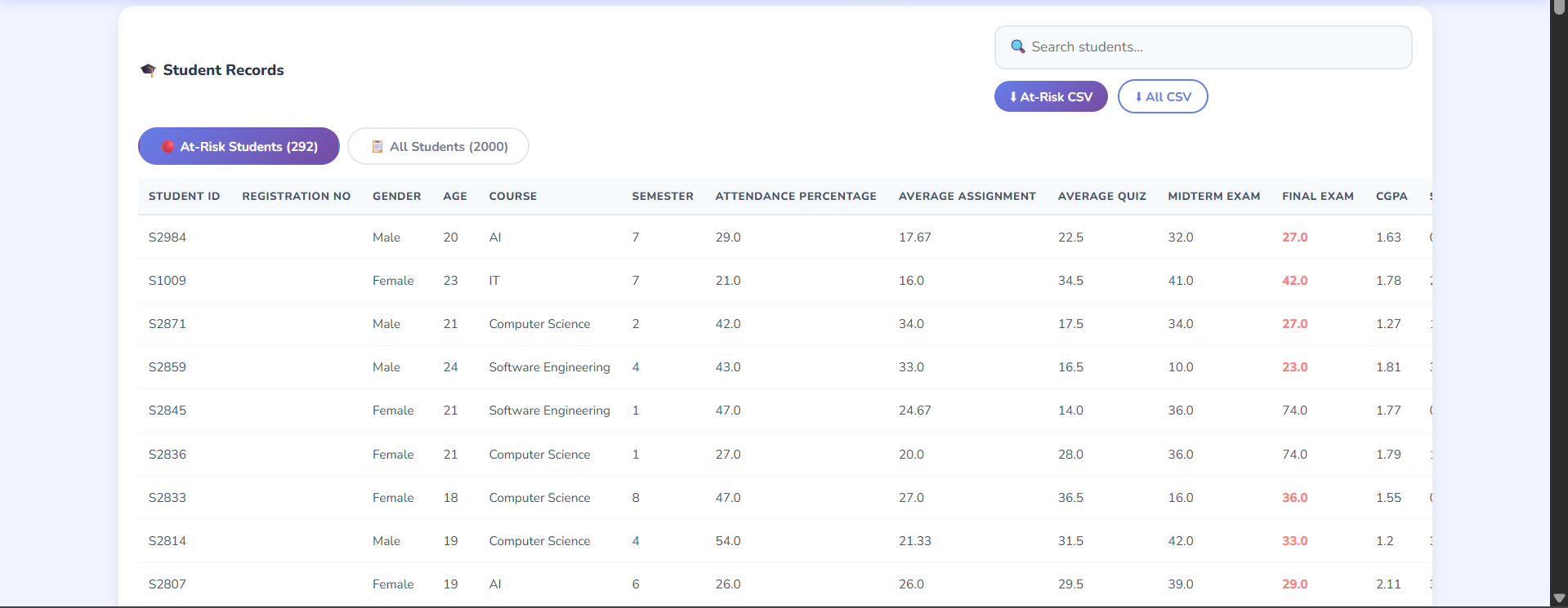

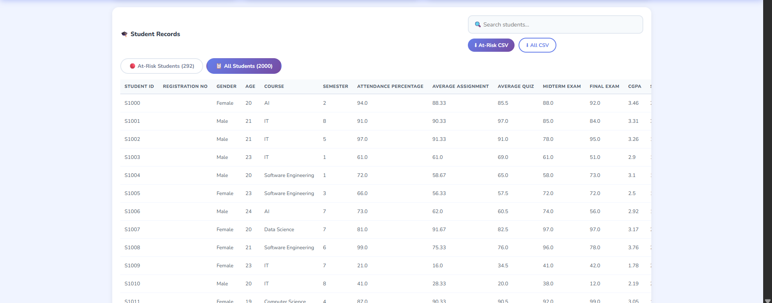

B.4 Teacher Dashboard - Search By Student ID
Teachers can use the Search students... bar for quick lookups or the CSV download buttons to export either the 'At-Risk' or 'All Students' roster for offline analysis.
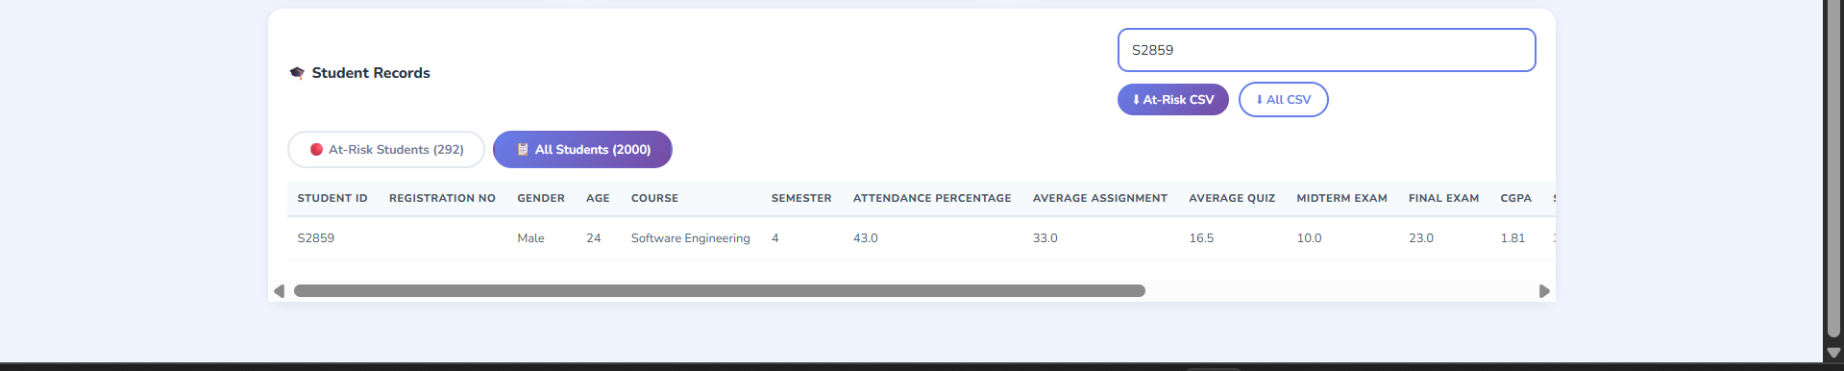

B.5 Student Dashboard - Banner, Mini-Cards, and Score Comparison
The Student View serves as an early-warning system that converts data into a structured recovery roadmap. It features a row of high-level metric cards, a sequence of 'Early Alert' banners for critical thresholds, and two comprehensive data visualizations. The experience concludes with 10 Personalized Recommendation cards that compare individual scores to class averages, providing specific, behavioral advice to help students improve their outcomes and avoid academic probation.

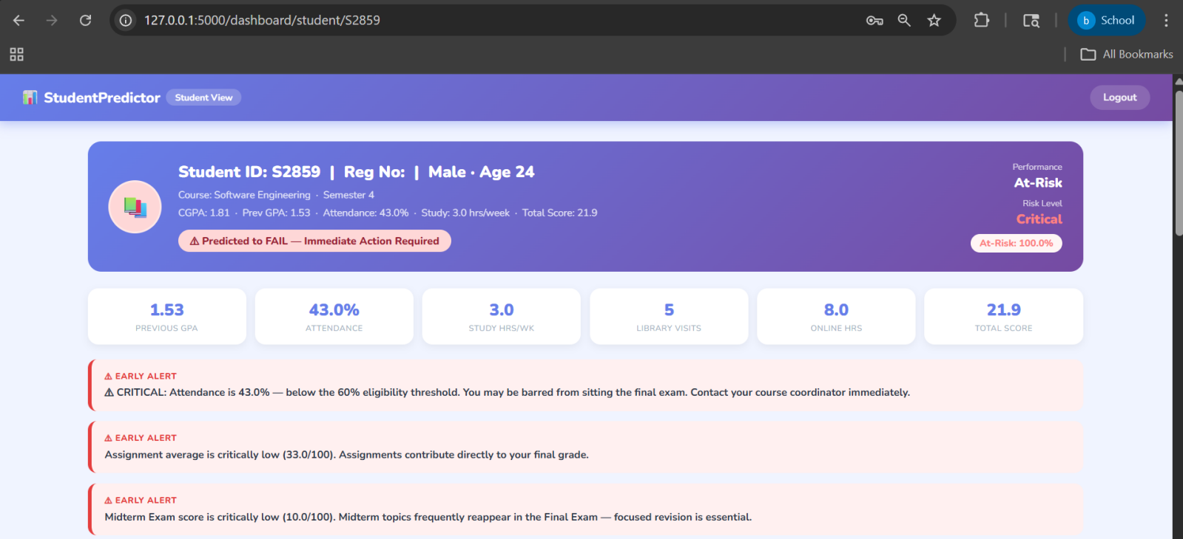
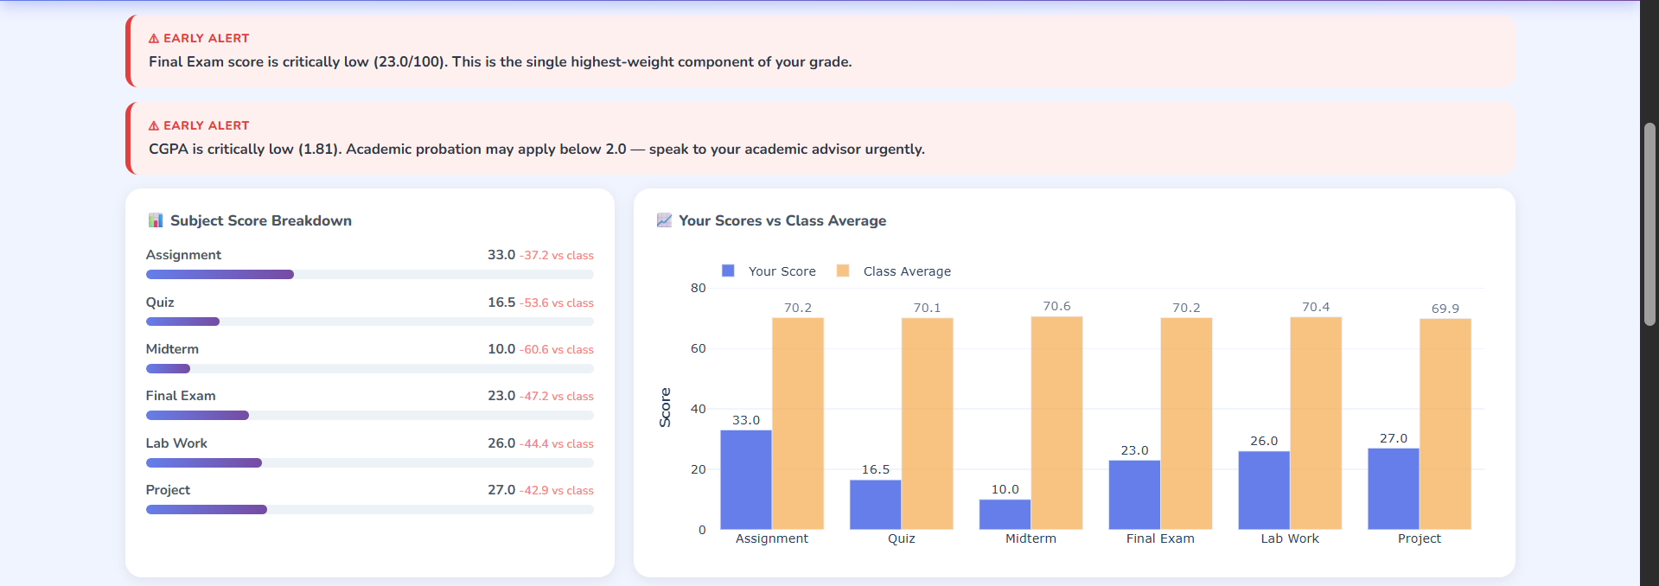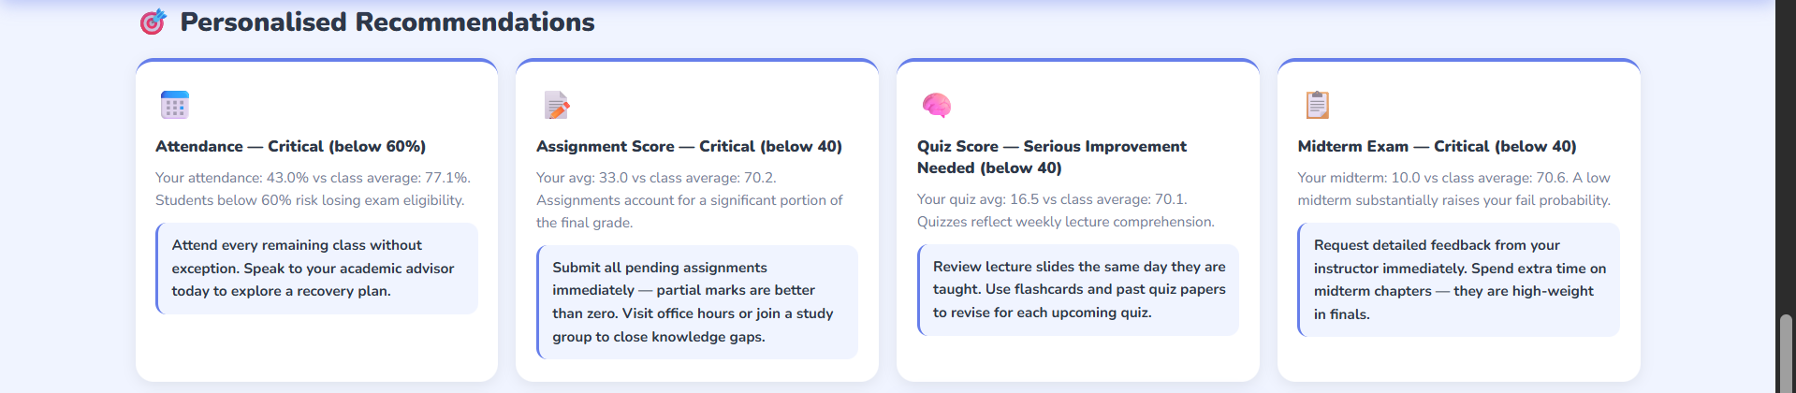
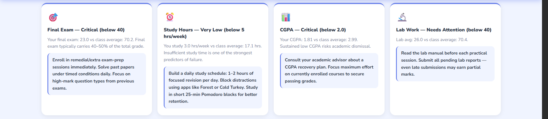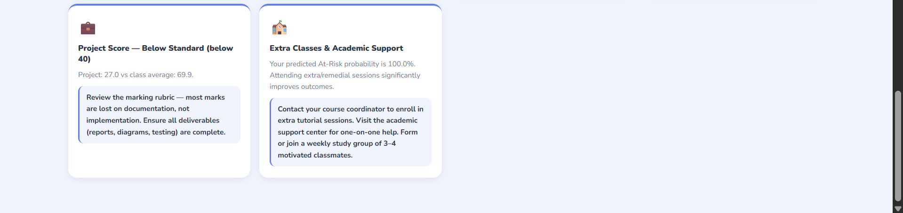
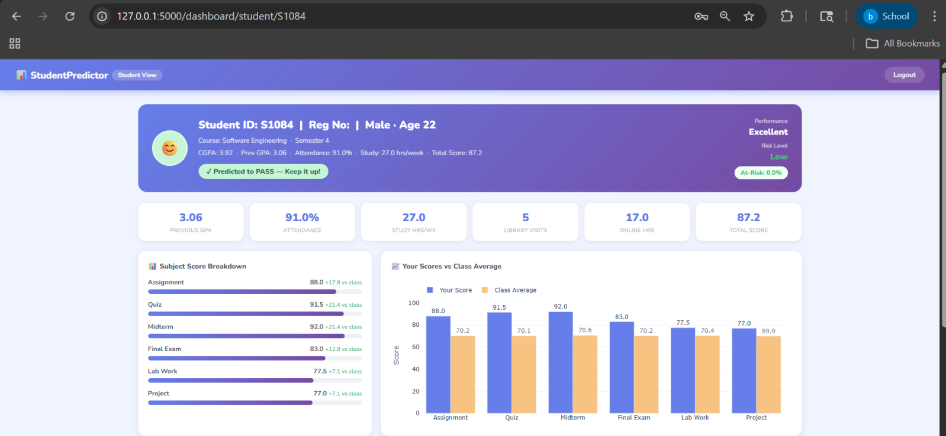

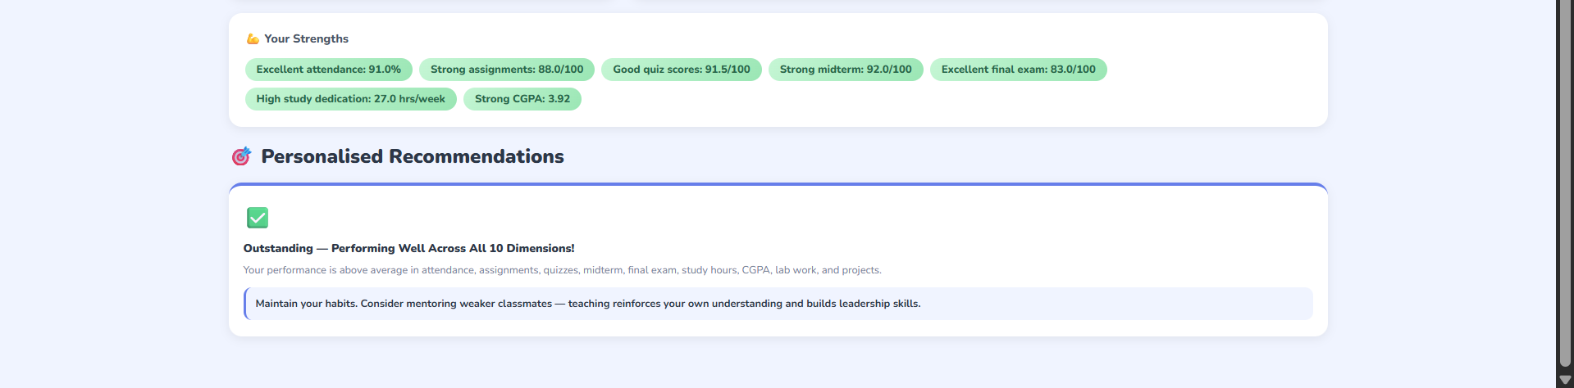

B.5 Student Dashboard - Recommendations Engine Output (Phase 4)
The Student Dashboard serves as a comprehensive early-warning and reinforcement system that converts complex predictive data into a structured roadmap for student success. Under the Phase 4 update, the interface dynamically adapts based on individual performance, leading with a color-coded Risk Level badge and a definitive fail probability percentage. For high-achieving students, a green status banner provides positive reinforcement with a "Predicted to PASS" message, while at-risk students are immediately met with urgent red Early Alert banners that flag critical thresholds like low attendance or failing CGPA.The experience is anchored by a row of high-level metric cards and two detailed comparative visualizations - a subject score breakdown and a grouped bar chart-that visually benchmark the student’s performance against the class average. For those requiring intervention, the dashboard generates up to ten personalized recommendation cards, each featuring a problem-area icon and a concrete action plan, such as implementing Pomodoro study blocks. Conversely, the system rewards top performers with a "Your Strengths" section filled with green pill badges and a single reinforcement card that encourages advanced goals, such as mentoring peers. By bridging the gap between raw data and behavioral change, this engine ensures every student receives tailored, actionable guidance to improve or maintain their academic standing.
AT RISK STUDENT (Recommendation Output):
AT EXCELLENT STUDENT (Recommendation Output):

